Contact:
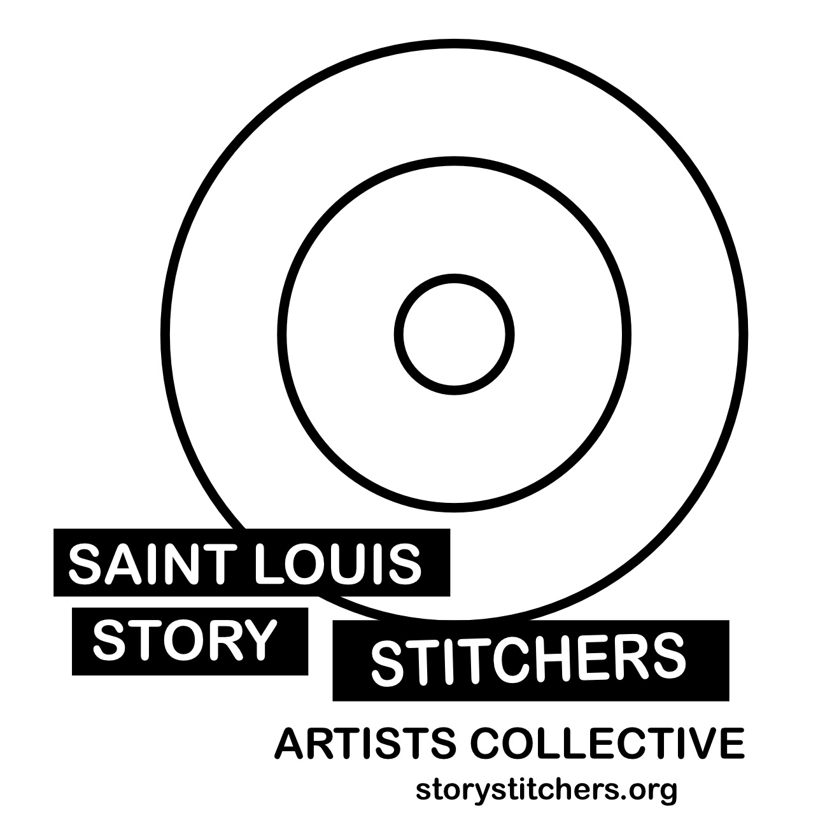
Susan Colangelo Emeara Burns
Executive Director Youth Program Director
Saint Louis Story Stitchers Emeara@storystitchers.org
Susanc@storystitchers.org 314-305-8679
706-255-5835

ST. LOUIS-BASED ORGANIZATION SAINT LOUIS STORY STITCHERS
ARTISTS COLLECTIVE PRESENTS PEACE IN THE PRAIRIE
Is the path towards peace through Missouri’s endangered prairies?

EVENT: PEACE IN THE PRAIRIE

Screening at Laumeier Sculpture Park June 15-29th with three live podcast recordings created in the park and then moving on to the National Blues Museum July 3rd for a screening with live performance elements.

ACKNOWLEDGEMENTS:
Peace in the Prairie is supported in part by an award from the National Endowment for the Arts. On the web at arts dot gov and by Missouri Arts Council, a State Agency.
Additional support was provided by the Spirit of St. Louis Women’s Fund, The Lewis Prize for Music, Missouri Foundation for Health, City of St. Louis Youth at Risk Crime Prevention grant, Steward Family Foundation, and Kranzberg Arts Foundation.

EVENT DETAILS:

Venue #1

EVENT:
Peace in the Prairie
Screening
Length: 1:10 minutes
Looping Video
(PG 13 for references to violence.)

LOCATION:
Laumeier Sculpture Park
12580 Rott Rd, St. Louis, MO 63127
Aronson Fine Arts Center
Whitaker Foundation Gallery

12580 Rott Rd, St. Louis, MO 63127

DATE:
June 15-29, 2021

HOURS:
Monday-Friday, and Saturdays, June 19, 2021 and June 26, 2021
10:00 AM-4:00 PM
ADDITIONAL ACTIVITIES:
StitchCast Studio Special Edition: Podcasts in the Park
PUBLISHING LOCATION: StitchCast Studio is Available on Podbean, Google Podcasts, apple podcasts, Spotify
Recording Live on the patio outside Kranzberg Education Lab
11:30 AM-12:30 PM June 15, 17 and 21
DATES and TOPICS/GUESTS:
StitchCast Studio Special Edition: Podcasts in the Park I & II
Bobby Norfolk recorded live at Missouri Botanical Garden’s Shaw Nature Reserve, September 20, 2020
Release: June 9 and June 10

StitchCast Studio Special Edition: Podcasts in the Park III
Stitchers Youth Council recorded live at Missouri Botanical Garden’s Shaw Nature Reserve, September 20, 2020
Video and Podcast Release: June 15

StitchCast Studio Special Edition: Podcasts in the Park IV
Stitchers Youth Council recorded in Zoom with artist Jordan Weber, May 13, 2021
Release: June 16

StitchCast Studio Special Edition: Podcasts in the Park V
Importance of parks and green spaces
Guest: Emma KIues, Vice President of Communications & Outreach,
Great Rivers Greenway
Recording live at Laumeier Sculpture Park, June 15, 11:30-12:30 Release: June 17

StitchCast Studio Special Edition: Podcasts in the Park VI
State of Missouri's prairies and the work of Missouri Prairie Foundation
Carol Davit, Executive Director
Recorded live at Laumeier Sculpture Park, June 17, 11:30-12:30
Release: June 21

StitchCast Studio Special Edition: Podcasts in the Park VII
Healing Power of Art + Nature
Lauren Ross, Executive Director, Laumeier Sculpture Park
Recording live at Laumeier Sculpture Park, June 21, 11:30-12:30
Release: June 23

Venue #2

EVENT:
Peace in the Prairie
LOCATION:
National Blues Museum
615 Washington Ave., St. Louis, MO 63101
Lumiere Place Legends Room

TICKETS:
Program includes live performance with video.
$10 per seat through the National Blues Museum.
https://nationalbluesmuseum.org/book-a-tour/
Space is limited. Masks are required.

DATE:
July 3, 2021

HOURS:
1:00-2:30
Length: 1:30 hour
(PG 13 for references to violence.)

PEACE IN THE PRAIRIE LANDING PAGE: https://storystitchers.org/peace-in-the-prairie/
Saint Louis Story Stitchers Artists Collective presents Peace in the Prairie, an original multimedia presentation newly expanded in its 3rd iteration, exploring the concepts of peace and violence, juxtaposing urban life as experienced by African American people living in the city of St. Louis, Missouri and the state's unique endangered prairie lands.
Peace in the Prairie is a lively, multimedia presentation that combines original music, discussion, and storytelling with videography.

Peace in the Prairie is unique to Missouri, generated by local artists and residents reflecting on loss and resilience in the human experience and rejuvenation in nature.

Story Stitchers lead artists involved in Peace in the Prairie include Troy Anthony, KP Dennis, Ntegrity, Master Storyteller Bobby Norfolk, Superhood, Susan Colangelo, and special guest artists, legendary St. Louis soul vocalist, soul and funk vocal legend Roland Johnson, and videographer Meghan Kirkwood, Assistant Professor of Art in the Sam Fox School of Design and Visual Arts at Washington University in St. Louis, joined by leading performing artists from Story Stitchers Youth Council including Emeara Burns and Branden Lewis, will treat you to a memorable and inspiring journey.

Over the past five years, the artists have explored and recorded native prairie landscapes via trips to Missouri prairie reserves including Shaw Nature Reserve of the Missouri Botanical Garden in Gray Summit, with the Missouri Prairie Foundation at Linden’s Prairie in Mt. Vernon, Missouri and Prairie Star Restoration Farm in Osage County, Prairie State Park in Mindenmines, Missouri in Barton County near Joplin, and Dunn Ranch Prairie of The Nature Conservancy in Hatfield, Missouri.

Peace in the Prairie expands the artistic body of work of African American artists in the Collective, addresses the community need of understanding violence while seeking peace, supports the exploration of new natural settings by both artists and audiences, and supports the greater understanding of Missouri's unique natural heritage in its native prairie lands.

Video Drops:
https://vimeo.com/543147256
https://vimeo.com/543148821
https://vimeo.com/543149946

@storystitchers presents Peace in the Prairie June 15-29 @laumeierstl
For details visit: https://storystitchers.org/peace-in-the-prairie/

@storystitchers presents Peace in the Prairie July 3 @nationalbluesmuseum
For details visit: https://storystitchers.org/peace-in-the-prairie/

ABOUT

About Saint Louis Story Stitchers Artists Collective

Saint Louis Story Stitchers Artists Collective is a non-profit organization engaged in urban storytelling. The mission of Saint Louis Story Stitchers is to document St. Louis through art and word to promote understanding, civic pride, intergenerational relationships and literacy.
Collective artists work alongside 16-24-year-old urban youth to collect stories, reframe and retell them using the arts to promote a better educated, more peaceful and caring society. Saint Louis Story Stitchers are a resident organization at Kranzberg Arts Foundation where members rehearse, present and perform in the Foundation's first-class spaces. The Collective also maintains the Stitchers Storefront Studio in the historic Loop District for recording, editing and publishing. Current projects focus on public health issues including gun violence. Learn more at storystitchers.org/

Contact: Susan Colangelo, President & Executive Director
susanc@storystitchers.org / 706-255-5835 Mobile

